# Capstone Project: Indian MIBOR Rate Modeling and Forecasting

## 1. Introduction

### 1.1 Project Overview

This capstone project aims to analyze and forecast the Indian Mumbai Interbank Offered Rate (MIBOR) using two prominent short-rate models: the Vasicek model and the Hull-White model. The project will involve collecting historical MIBOR data, estimating model parameters, simulating future interest rate paths, and deriving interest rates for specific future tenors (3.5, 4.5, and 5.5 years). A critical component will be the comparative analysis of both models, assessing their strengths, weaknesses, and suitability for the Indian MIBOR market based on historical data fit and forecasting capabilities.

### 1.2 Objectives

* To collect and process two years of historical Indian MIBOR data.
* To understand the theoretical foundations of the Vasicek and Hull-White short-rate models.
* To estimate the parameters for both models using the collected historical MIBOR data.
* To simulate future MIBOR rate paths and derive interest rates for 3.5, 4.5, and 5.5-year periods using the estimated parameters.
* To visualize the historical data, simulated paths, and derived interest rates through appropriate graphs.
* To conduct a comparative analysis of the Vasicek and Hull-White models, identifying which model provides a better fit and more reasonable forecasts for the Indian MIBOR market, along with a detailed justification.

## 2. Theoretical Background

### 2.1 Understanding Interest Rate Models

Interest rate models are mathematical frameworks used to describe the evolution of interest rates over time. They are crucial for pricing interest rate derivatives, valuing fixed-income securities, and managing interest rate risk. Short-rate models, which model the instantaneous interest rate, are a fundamental class of these models.

### 2.2 The Vasicek Model

The Vasicek model (1977) is a single-factor, mean-reverting short-rate model. It assumes that the short-term interest rate tends to revert to a long-term mean.

Stochastic Differential Equation (SDE):

drt​=κ(θ−rt​)dt+σdWt​

Where:

* rt​: Short-term interest rate at time t
* κ: Rate of mean reversion (speed at which rt​ reverts to θ)
* θ: Long-term mean interest rate
* σ: Volatility of the interest rate (diffusion coefficient)
* dWt​: Wiener process (standard Brownian motion)

**Key Characteristics:**

* **Mean Reversion:** Interest rates tend to move back towards a long-term average.
* **Normally Distributed Rates:** The model implies that interest rates follow a normal distribution, which means they can become negative. This is a significant drawback in some contexts.
* **Analytical Tractability:** It allows for closed-form solutions for bond prices and other derivatives, making it computationally efficient.

### 2.3 The Hull-White Model

The Hull-White model (1990) is an extension of the Vasicek model, making it more flexible by allowing the mean reversion level to be time-dependent. This makes it an affine term structure model that can perfectly fit the initial yield curve.

Stochastic Differential Equation (SDE):

drt​=[θ(t)−κrt​]dt+σdWt​

Where:

* rt​: Short-term interest rate at time t
* κ: Rate of mean reversion
* θ(t): Time-dependent drift term, chosen to fit the observed initial term structure. This is the key difference from Vasicek.
* σ: Volatility of the interest rate
* dWt​: Wiener process

**Key Characteristics:**

* **Time-Dependent Mean Reversion:** The ability to fit the initial yield curve exactly is a significant advantage, as it ensures that the model's current predictions align with market observations.
* **Normally Distributed Rates:** Like Vasicek, rates can become negative, which is a conceptual issue for interest rates.
* **Calibration:** Calibration involves determining κ and σ from historical data and then determining θ(t) from the current market yield curve.

## 3. Methodology

### 3.1 Data Collection

* **Data Source:** Obtain daily historical Indian MIBOR (e.g., 1-month MIBOR) data for the last two years (e.g., May 2023 - Apr 2025). Reliable sources of [Financial Benchmarks India Pvt Ltd](https://www.fbil.org.in/#/home). Please refer attached file of data



* **Data Cleaning:** Handle missing values, outliers, and ensure consistent data frequency.

### 3.2 Parameter Estimation

#### 3.2.1 Vasicek Model Parameter Estimation

The parameters (κ, θ, σ) can be estimated using various methods, typically Ordinary Least Squares (OLS) regression on the discretized form of the SDE.

Discretized Vasicek SDE:

rt+Δt​−rt​=κ(θ−rt​)Δt+σΔt​ϵt​

Rearranging for regression:

Δtrt+Δt​−rt​​=κθ−κrt​+Δt​σ​ϵt​

Let Yt​=Δtrt+Δt​−rt​​ and Xt​=rt​.

We can run a linear regression: Yt​=β0​+β1​Xt​+error.

Then, β1​=−κ and β0​=κθ.

From these, we can derive κ and θ. σ can be estimated from the standard deviation of the residuals.

#### 3.2.2 Hull-White Model Parameter Estimation

For the Hull-White model, κ and σ are typically estimated from historical data, similar to the Vasicek model, as they represent the mean reversion speed and volatility. The time-dependent drift θ(t) is calibrated to fit the current market yield curve. Since we are generating future rates, we will estimate κ and σ from historical MIBOR data. For θ(t), we can assume a constant value for simplicity in a pure forecasting context, or, ideally, calibrate it to the current Indian government bond yield curve for various maturities. For this project, estimating κ and σ from historical MIBOR and using a constant θ (perhaps the estimated long-term mean from Vasicek or the current MIBOR rate) for simulation would be a good starting point, acknowledging the simplification.

### 3.3 Interest Rate Generation (Simulation)

#### 3.3.1 Discretization and Simulation

Both models can be simulated using their discretized forms. For a small time step Δt:

* **Vasicek:** rt+Δt​=rt​+κ(θ−rt​)Δt+σΔt​Zt​
* Hull-White: rt+Δt​=rt​+[θ(t)−κrt​]Δt+σΔt​Zt​  
  Where Zt​ is a standard normal random variable.

**Steps for Simulation:**

1. Set the initial rate (r0​) to the latest available MIBOR rate.
2. Choose a small time step (Δt, e.g., 1/252 for daily steps if data is daily).
3. Simulate a large number of paths (e.g., 1,000 to 10,000 paths) over the desired period (e.g., 5.5 years).
4. For each path, calculate the instantaneous rate at each time step.

#### 3.3.2 Deriving Future Interest Rates

To get the interest rate for a specific tenor (e.g., 3.5 years), you would typically use the average of the simulated short rates over that period, or more accurately, derive the zero-coupon bond price from the simulated paths and then extract the yield.

For a zero-coupon bond maturing at T, its price P(t,T) can be calculated as:

P(t,T)=EQ[e−∫tT​rs​ds∣Ft​]

The yield to maturity Y(t,T) is then:

Y(t,T)=−T−tlnP(t,T)​

For this project, a simpler approach could be to average the simulated short rates over the desired tenor to get a proxy for the forward rate, then annualize it. For example, for a 3.5-year rate, average the simulated daily rates over the next 3.5 years for each path, and then average these averages across all paths.

### 3.4 Graph Plotting

* **Historical MIBOR Data:** Plot the 2 years of historical MIBOR rates.

Excel Base Graph

**Python Base Graph**

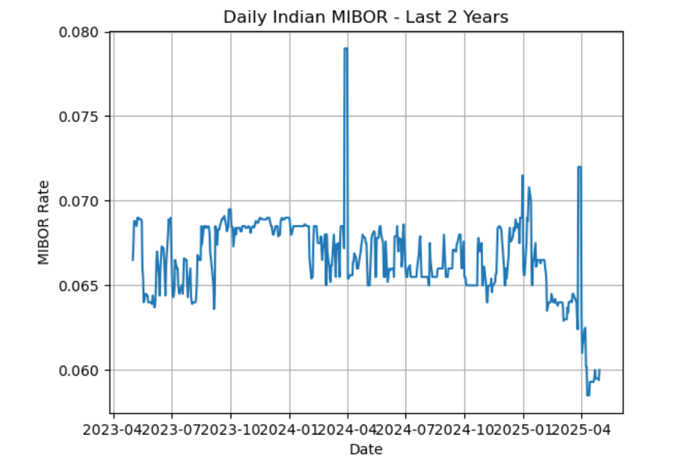

* **Simulated Paths:** Plot a few (e.g., 5-10) representative simulated interest rate paths for both models to show their stochastic nature.
* **Forecasted Rates:** Plot the derived 3.5, 4.5, and 5.5-year interest rates for both models, potentially with confidence intervals (e.g., 5th and 95th percentiles from simulations).
* **Distribution of Rates:** Plot histograms of the simulated rates at the 3.5, 4.5, and 5.5-year marks to show their distribution.

## 4. Expected Results and Analysis

### 4.1 Vasicek Model Results

* Present the estimated parameters (κ, θ, σ).
* Discuss the implications of these parameters (e.g., speed of mean reversion, long-term average).
* Show the simulated paths and the derived 3.5, 4.5, and 5.5-year interest rates.
* Analyze the distribution of simulated rates, noting the possibility of negative rates.

### 4.2 Hull-White Model Results

* Present the estimated parameters (κ, σ).
* Discuss how θ(t) was handled (e.g., constant, or calibrated to a proxy yield curve).
* Show the simulated paths and the derived 3.5, 4.5, and 5.5-year interest rates.
* Analyze the distribution of simulated rates.

**4.3 Excel base Implementation of this Project: -**



**4.3 Python base Implementation of this Project: -**



## 5. Model Comparison and Justification

### 5.1 Criteria for Comparison

* **Parameter Stability:** How robust are the estimated parameters to different historical periods?
* **Fit to Historical Data:** How well do the models' implied dynamics match the observed historical MIBOR movements? (e.g., using residuals from parameter estimation).
* **Forecasting Realism:** Do the simulated future rates appear plausible given the current economic environment and historical trends?
* **Negative Rates:** Does the model produce negative rates frequently? How problematic is this for the Indian context?
* **Computational Complexity:** Which model is easier to implement and run simulations for?
* **Flexibility:** Can the model be easily extended or calibrated to fit market data (e.g., the initial yield curve)?

### 5.2 Which Model is Better and Why?

Based on the analysis, provide a clear recommendation.

* **Arguments for Hull-White:** Likely to be preferred due to its ability to fit the initial yield curve, which is crucial for practical applications like derivative pricing. It offers more flexibility in capturing market realities.
* **Arguments for Vasicek:** Simpler to implement and understand. If the historical MIBOR exhibits strong mean reversion and the possibility of negative rates is acceptable or rare, it might offer a reasonable first approximation.
* **Contextual Considerations:** Discuss how the specific characteristics of the Indian MIBOR market (e.g., volatility, mean-reverting behavior, policy interventions) might favor one model over the other. For instance, if the RBI actively manages short-term rates, a mean-reverting model might be more appropriate.

## 6. Conclusion

Summarize the key findings, including the estimated parameters, the forecasted interest rates, and the comparative analysis of the two models. Reiterate the recommended model and its justification.